**CHAPTER 20: ASTRONOMY AND COSMOLOGY**

**Luminosity; luminous flux**

Stars are described as LUMINOUS because they emit electromagnetic waves.

The LUMINOSITY of a luminous (“hot”) object is defined as the amount of electromagnetic wave energy emitted by the object per second i.e. it is the emission Power of the object and is thus measured in Watts (W). It is a measure of the absolute “brightness” of the object.

FLUX (F) is Power per unit area (an Intensity). For a spherical emitter of radius R (and thus surface area of 4R2), this means that

F = L / 4R2

**Stefan’s Law**

The Stefan-Boltzmann Law (sometimes simply called Stefan’s Law) states that the Flux from a hot object is proportional to the fourth power of the absolute temperature, T. Strictly speaking, this applies only to idealised radiation emitters (referred to as “black bodies”); the constant of proportionality is the Stefan-Boltzmann constant, , which has a value of 5.67 x 10-8 W m-2 K-4:

F =  T4

Therefore, for an emitted with surface area A, the Luminosity will be given by

L =   T4

and in the case of a spherical emitter (such as a star) of radius R, this becomes

L = 4  R2  T4

**Wien’s Displacement Law; Planck Curves**

Black bodies of a particular temperature T will emit radiation over a range of wavelengths (a radiation distribution known as a Planck Curve):

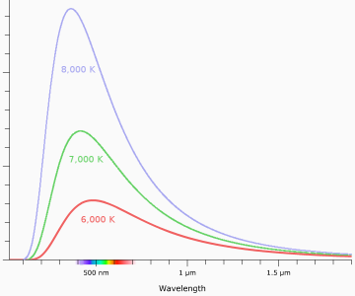

Figure 1: Planck curves

The distribution peaks at a wavelength max which is determined by the reciprocal of the absolute temperature T of the object. This is known as Wien’s Displacement Law. The constant of proportionality has a value of 2.90 x 10-3 m K:

max  = 2.90 x 10-3 / T

The greater the temperature, the larger the area under the curve, suggesting that more radiation is being emitted altogether, consistent with the Stefan-Boltzmann relation. Refer to Figure 1 and consider the T = 8000 K and the T = 6000 K graphs. The area beneath the T = 8000 K graph is (8000/6000)4 times that beneath the T = 6000 K graph, i.e. 3.16 times greater.

The Sun’s photosphere is at a temperature of a little under 6000 K; notice that the Planck Curve for this temperature peaks at a wavelength lying in the visible part of the electromagnetic spectrum.

Wien’s Displacement Law enables astronomers to determine the temperature of a star from observations of the light (and other radiation) emitted by that star.

Having determined the temperature, T, one can then use the Stefan-Boltzmann relation to determine the Luminosity, L. This is a measure of the actual amount of radiation being emitted by the star. By measuring the actual amount of radiation received per second per unit area (i.e. the flux, F), one can then calculate how big the star must be (the surface area from which the radiation is being emitted) in order to produce that amount of Flux.

Worked example: Proxima Centauri, the nearest star to the Sun

Data:

Parallax angle = 0.8 seconds of arc

Peak wavelength, max = 967 nm

Flux measured at Earth = 3.56 x 1011 W m-2

1. Calculate the distance to Proxima Centauri.
2. Calculate its surface temperature.
3. Calculate the Flux at the star’s surface
4. Hence calculate the radius of the star.

Solution:

1. D (in parsecs) = 1 / angle of parallax in seconds of arc = 1.25 pc = 3.85 x 1016 m
2. From Wien’s Displacement Law, T = 2.90 x 10-3 m K / 967 x 10-9 m = 3000 K
3. From Stefan’s Law, F =  T4 = 5.67 x 10-8 x 8.10 x 1013  = 4.6 x 106  W m-2
4. Flux measured at a distance of 3.85 x 1016 m is 3.56 x 10-11 W m-2.

So, Fat Earth  / Fstar’s surface  =. (radius of star)2 / (distance to star)2

* Radius of star = 1.07 x 108 m

**Standard Candles**

Standard Candles are types of stars or galaxies for which the Luminosity (the absolute brightness) can be determined directly from observations. By measuring the observed brightness and comparing it to the absolute brightness of the object, it is possible to determine how far away that object is.

The best-known and most widely used Standard Candles are Cepheid Variables and Type 1a Supernovae.

Cepheid Variables (named after the star Delta Cephei) pulsate and vary in brightness with a frequency that is related to the star’s Luminosity. The periods of some Cepheids have been measured as a few days, others a few months. Once the absolute brightness has been found from the observed period of the pulsation, it can be compared with the brightness the star appears to have as observed from the Earth and hence the distance can be determined.

Type 1a supernovae occur when one of the stars (a white dwarf) in a binary system gains mass, becomes unstable and catastrophically explodes emitting vast quantities of light and other electromagnetic energy in the process. The maximum absolute brightness achieved is related to the rate at which the emission fades (the so-called Light Curve). Thus, again, once the absolute brightness is known, a comparison with how bright the object appears to be from the Earth will yield its distance. Because they are so bright, these objects can be easily seen in distant galaxies, so that distances well beyond the limits of the Milky Way can be established.

**Application of Newtonian Mechanics and Gravitation to Solar System and beyond**

Newton’s law of Universal Gravitation states that two masses, M and m, whose centres are separated by a distance r, will mutually attract with a gravitational force given by

F = G M m / r2

where G, the Universal Gravitational Constant, = 6.67 x 10-11 N m2 kg-2.

One of the great triumphs of the law was to demonstrate consistency with Kepler’s Laws of Planetary Motion, formulated empirically some 70 years earlier. Kepler’s Laws state that the planets move about the Sun in elliptical orbits and whilst Newton’s Law can be applied to such orbits, for simplicity we consider a planet moving in a circular orbit. If the radius of the orbit is r, then from rotational mechanics, the planet will experience a constant centripetal force of mv2/r. This origin of this force is the gravitational attraction given by Newton’s equation and by equating the two formulae it is possible to show that

T2 = 4 2 r3 / G M

i.e. that T2  r3 as stated by Kepler’s 3rd Law. Newton's Law, when combined with his Laws of Motion, was applied to other objects observed to be in gravitational orbits with great success. The movements of planetary satellites, binary star systems, galactic spiral arms and even clusters of galaxies themselves have all been shown to be consistent with the relationships. Famously, the relationships demonstrated orbital irregularities in the motion of the planet Uranus, high led to the discovery of the planet Neptune beyond it. Similar anomalous behaviour in the rotations of spiral galaxies observed by Vera Rubin has led to the speculation of the existence of Dark Matter.

Worked example: the mass of the Sun

From the orbital data for the Earth, calculate the mass of the Sun (assuming a circular orbit).

Solution:

Radius of Earth’s orbit = 150 x 106 km

Orbital period of earth = 1 year = 3.2 x 107 s

* From Kepler’s 3rd Law (above), M = 1.96 x 1030 kg

**Doppler Shift; Hubble’s discovery**

When a source of waves moves away from an observer (in a stationary medium), the observer will receive waves of a longer wavelength (and thus lower frequency) than those emitted by the source. If the source moves towards the observer then the observed wavelength is shorter (frequency is higher). This is called Doppler Shift. For example, with sound waves this can be perceived as a change in the pitch of the emitted sound.

The greater the speed of the source, v, the greater the change in the wavelength  (or frequency, f, whichever is being measured) of the waves received by the observer:

/ = f/f = v/c

in which c is the velocity of the emitted waves (a relationship strictly only true for if c is much greater than v).

The dark lines observed in the visible light spectra of stars and galaxies are caused by the absorption of specific frequencies (colours) by elements present in those objects, enabling astronomers to determine their composition. In the 1920s, Edwin Hubble discovered that the absorption lines for distant galaxies were shifted towards the red end of the colour (emission) spectrum. This Red Shift indicated that the galaxies were moving away (receding) from the Earth. But there were two particular features of his discovery that made a special impact:

1. Galaxies were receding in all directions.
2. The more distant the galaxy, the higher its recessional velocity.

(The distances to the galaxies were established using Standard Candles, especially Cepheid Variables.)

**Hubble’s Law**

These observations have led to the conclusion that the universe began with a Big Bang and what Hubble observed was the expansion of space itself. A helpful picture is that of the infinite scaffolding by M C Escher:

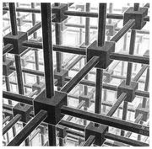

Figure 2: M C Escher drawing

No matter which junction you view from, if each scaffold pole is expanding, junctions in all directions will appear to recede. Note that, in effect, the junctions themselves do not move: the space in between them does. Also, more distant junctions (with more expanding poles between them and the observer) will appear to recede with greater speeds.

In such a model, the speed of “recession” (expansion) is proportional to the distance of the observed galaxy and observations are by and large consistent with this:

V = Ho d

in which the constant of proportionality, Ho, is known as the Hubble Constant, the value of the gradient of the graph of v plotted against d (Figure 3):

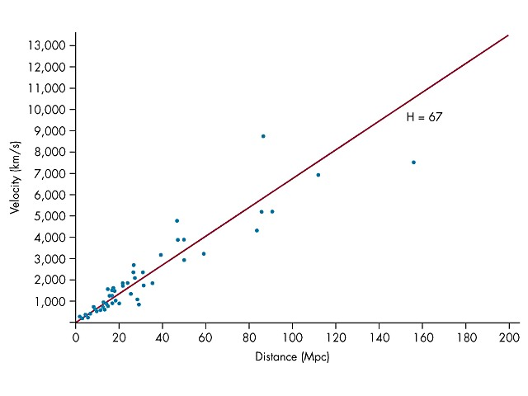

Figure 3: Hubble’s Law

Recent measurements (see graph) suggest a value of Ho of a little over 67 km s-1 Mpc-1

Given that, in the observable universe, the greatest distance from which radiation could be received is given by the speed of light x the age of the universe, it follows that the age of the universe will be given by 1/Ho. For the value of Ho quoted, this equates to an age of

When measuring the red shifts of distant galaxies, the calculated velocities thus more properly indicate the rate at which the intervening space is stretching. The value of  (or f/f) is called the Cosmological Red Shift, z, indicating that the space has expanded by a factor of 1 + z in order to produce the observed Doppler Shift.

Worked example: quasar 3C273

The quasar 3C273 was the first object of its kind to be identified. So called because they were star-like but much more luminous (“quasi-stellar objects”) they are now known to consist of supermassive black holes that draw in a huge disc of orbiting gas, causing large emissions of radiation across a wide range of wavelengths. Their spectra exhibit large red shifts.

1. One emission line in the spectrum of 3C273 appears at a wavelength of 475.0 nm; in the laboratory the same line is measured at 410.2 nm. Calculate the recessional velocity of the quasar.
2. Using the value of H0 quoted above, hence calculate the distance of 3C273.

Solution:

1.  = 475.0 – 410.2 nm = 64.8 nm.

From Doppler equation, / = v/c, this gives v = 4.74 x 107 ms-1 or 4.74 x 104 km s-1.

1. Assume a value of H0 of 67 km s-1 Mpc-1.

* d = 4.74 x 104 km s-1 / 67 km s-1 Mpc-1 = 707 Mpc.

**Big Bang model; Cosmic Microwave Background Radiation**

In the 1940s, George Gamow suggested that the observed ratio of hydrogen to helium in the universe could be explained by assuming the universe was much hotter and denser a long time ago, consistent with the idea of a Big Bang origin stemming from Hubble’s work. His theory predicted the existence of a “leftover” radiation which was eventually discovered by chance in 1965. This is today known as the Cosmic Microwave Background Radiation and it has the biggest cosmological red shift. It was produced when the early universe had cooled down to about 3000K, low enough for electrons to combine with protons to produce atoms, a process resulting in the emission of photons of wavelengths around 1 mm. Because of cosmological expansion, the wavelength is now a thousand times bigger (millimetres) and the temperature a thousand times smaller, about 3 K.

Refinements to the Big Bang model have included a period of Inflation very early on which gave rise to the eventual clumping of matter, which accounts for the later existence of stars and galaxies (and planets and humans). The Cosmic Background Explorer satellite revealed such clumping (measured as tiny temperature fluctuations in the background radiation) and further evidence is still being sought to confirm Inflation as a part of the model.

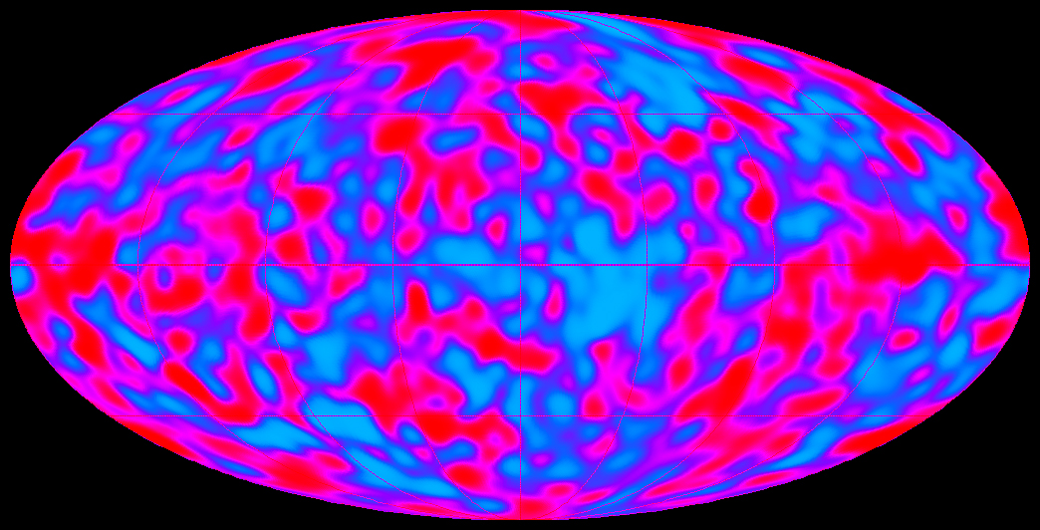

Figure 4: COBE satellite image